**Lab 1: Android Option Menu**

# **Introduction**

The group of menu options for an activity is called the Android Options Menu. The options menu enables placing actions that have an application-wide effect.Options By overriding the onCreateOptionsMenu() method, a menu is produced. By using the inflate() function of the MenuInflater class, the menu resource is inflated. Override the onOptionsItemSelected() function to respond to menu options.

**Let’s get Started:**

In this Exercise we will be implementing an **Options Menu** in the android application.

In android, to define **options menu**, we need to create a new folder **menu** inside of our project resource directory (**res/menu/**) and add a new XML (**menu.xml**) file to build the menu.

**Step 1:** open newly created xml (**menu.xml**) file and write the code like as shown below.

**menu.xml**

*<?*xml version="1.0" encoding="utf-8"*?>*<menu xmlns:android="http://schemas.android.com/apk/res/android"  
 xmlns:app="http://schemas.android.com/apk/res-auto">  
  
 <item  
 android:id="@+id/overflowMenu"  
 android:title=""  
 android:icon="@drawable/ic_baseline_more_vert_24"  
 app:showAsAction="always">  
 <menu>  
 <item  
 android:id="@+id/op1"  
 android:title="Save" />  
 <item  
 android:id="@+id/op2"  
 android:title="Open" />  
 <item  
 android:id="@+id/op3"  
 android:title="Delete" />  
 </menu>  
 </item>  
</menu>

**Step 2:**

Open **MainActivity.kt** file and write the following code.

**MainActivity.kt**

**package** com.example.demooptionmenu5apr  
**import** android.os.Bundle  
**import** android.support.v7.app.AppCompatActivity  
**import** android.view.Menu  
**import** android.view.MenuItem  
**import** android.widget.Toast  
  
**class** MainActivity : AppCompatActivity() {  
 **override fun** onCreate(savedInstanceState: Bundle?) {  
 **super**.onCreate(savedInstanceState)  
 setContentView(R.layout.*activity_main*)  
 }  
  
 **override fun** onCreateOptionsMenu(menu: Menu?): Boolean {  
 *menuInflater*.inflate(R.menu.*menu*,menu)  
 **return super**.onCreateOptionsMenu(menu)  
 }  
  
 **override fun** onOptionsItemSelected(item: MenuItem): Boolean {  
 **when** (item.*itemId*){  
 R.id.*op1* -> Toast.makeText(**this**,**"Save Option Selected"**,Toast.*LENGTH_SHORT*).show()  
 R.id.*op2* -> Toast.makeText(**this**,**"Open Option Selected"**,Toast.*LENGTH_SHORT*).show()  
 R.id.*op3* -> Toast.makeText(**this**,**"Delete Option Selected"**,Toast.*LENGTH_SHORT*).show()  
 }  
 **return super**.onOptionsItemSelected(item)  
 }  
}

**Step 3: Check Output on Android Emulator and it should look like as given below.**

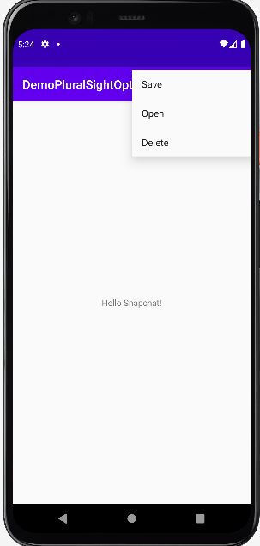 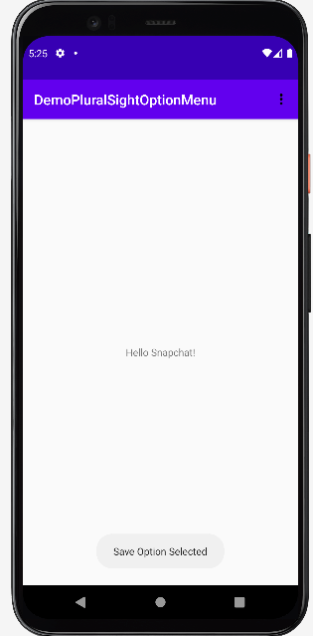

**Voila!!** We have successfully completed this lab.